**Vonage Video Call Component**

You can create a developer account  
<https://developer.vonage.com/en/home>

Then create a Project , then we get ApiKey and ApiSecret .

You can clone the repositories from here.

<https://www.sdeiscm.com/MS-Component/VideoCallFrontend>

<https://www.sdeiscm.com/MS-Component/VideoCallBackend>

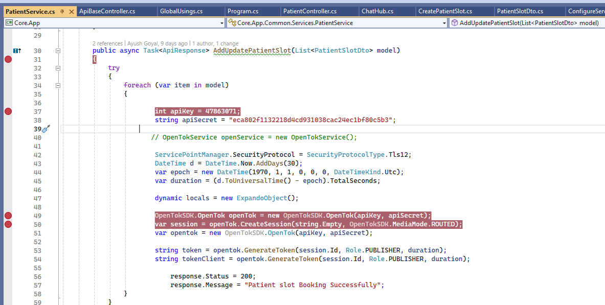

Change apikey and apisecret after creating a Vonage account.

Run this method AddUpdatePatientSlot() and generate a Token and SessionID.

Replace the new Token and SessionID in the angular frontend code.

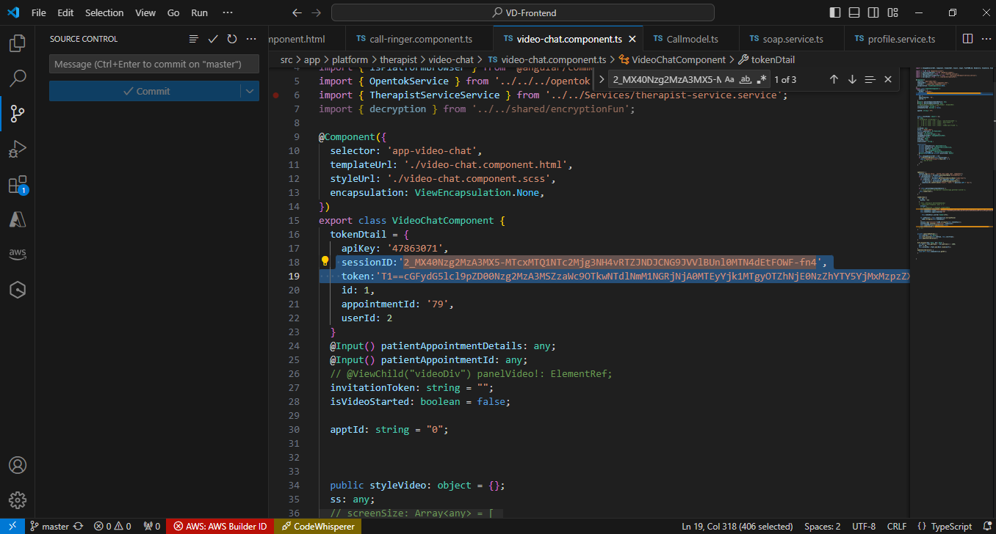

Change the Token and SessionID here in the Video-chat.component.ts .

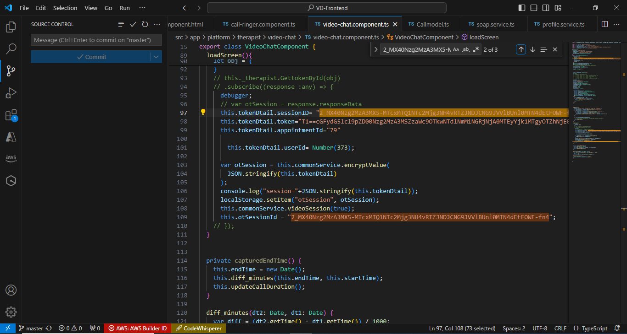

We have deployed this component on the Staging website

API URL

<https://ms.stagingsdei.com:8071/swagger/index.html>

Web Frontend URL

<https://ms.stagingsdei.com:8072/videocall>

This is a demo video call screenshot

